Radiation Shielding Design for Non-Standard Synchrotron Beamlines
Moraes I. C.¹, F. A. Bacchim Neto¹
¹Brazilian Center for Research in Energy and Materials, Campinas, SP, Brazil.

Abstract

Machine dosimetry in synchrotrons often focuses on shielding design for standard X-ray beamlines. However, non-traditional beamlines, such as those extracting infrared (IR), visible, or ultraviolet (UV) radiation, present unique challenges that require customized shielding approaches. This work presents the radiation shielding calculations and design solutions developed designed using FLUKA.CERN [1] for three distinct beamlines at Sirius: IMBUIA, CARCARÁ, and SAPÊ. IMBUIA is a mid-IR beamline where radiation is extracted at the same level of the storage ring from a low-field bending magnet and reflected at approximately 90º inside the accelerator tunnel. The shielding strategy involved tungsten and lead elements within the accelerator’s concrete walls, as well as a small external shielding hutch to mitigate photon and neutron contributions. The primary challenge was achieving a satisfactory dose reduction at the hutch tube exit after multiple perpendicular scatterings. CARCARÁ extracts into two regions: 11 keV in the conventional extraction and visible light at 90º from the machine, but in this case, the extraction is through the storage ring ceiling. The shielding assessment considered electron loss, synchrotron photon scattering, and Gas Bremsstrahlung, leading to the design of elements such as masks, walls, and shutters with optimized thicknesses for different shielding materials, including tungsten, steel, and lead. SAPÊ, a UV-C beamline, required containment of scattered radiation within the concrete shielding of the storage ring while allowing only UV extraction via mirrors installed inside the concrete shielding, in the front-end region. To ensure compliance with dose limits outside the shielding, a lead mask and a steel wall were implemented inside the ring. For all three cases, biasing techniques and geometric optimizations were applied to achieve satisfactory simulation results. The effectiveness of these shielding solutions was confirmed through experimental measurements, validating the accuracy of the simulations and design choices. This study highlights the importance of adapting radiation protection strategies, ensuring safe operation and compliance with radiological constraints in synchrotron facilities.

- Introduction

Radiation shielding in synchrotron facilities traditionally focuses on standard X-ray beamlines, primarily addressing photon and neutron shielding in conventional extraction geometries. However, synchrotron sources incorporate diverse beamlines extracting radiation beyond X-rays, including infrared (IR), visible, and ultraviolet (UV) light. These non-traditional beamlines pose distinct radiological challenges due to unconventional extraction angles, radiation types, and spatial constraints, necessitating tailored shielding solutions to ensure operational safety and regulatory compliance.
This work presents a comprehensive approach to radiation shielding design for three novel beamlines at the Sirius synchrotron light source: IMBUIA (mid-IR), CARCARÁ (visible and 11 keV X-rays), and SAPÊ (UV-C). Utilizing the Monte Carlo particle transport code FLUKA.CERN [1], complex shielding geometries were modeled with biasing techniques to optimize computation.

- IMBUIA Beamline (Mid-IR)

IMBUIA (Infrared Micro- and Nano-spectroscopy Beamline for Ultra-resolved Imaging Applications) represents the inaugural mid-infrared beamline at the Sirius synchrotron facility. It supports advanced spectroscopic analysis at both micro- and nanoscale spatial resolutions through two experimental endstations: IMBUIA-micro, optimized for chemical mapping of microscale samples, and IMBUIA-nano, developed for nanoscale vibrational and optical characterization. The beamline extracts synchrotron radiation from a 0.56 T low field bending magnet. The photon beam is initially reflected by a primary mirror (M1) positioned near the extraction port, then passes through the concrete shielding of the storage ring enclosure. Outside the ring, two additional mirrors (M2 and M3) housed within a radiation shielding hutch direct the beam toward the experimental stations.

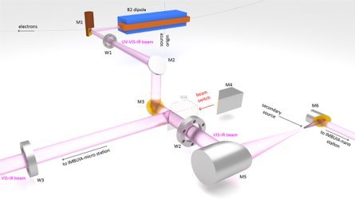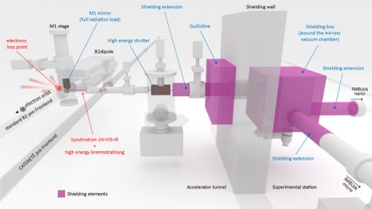
Fig.1 – Schematic overview of the IMBUIA layout showing mirror positions, extraction path, and shielding elements.

Designing effective shielding for IMBUIA required addressing the complexity arising from its unique beam extraction geometry and the confined spatial conditions of the accelerator tunnel. Notably, the beam undergoes approximately 90º reflection inside the tunnel, generating multiple perpendicular scattering events involving photons and secondary particles such as neutrons, which could potentially expose personnel if not adequately shielded. Hence, the shielding strategy focused on containing scattered radiation within the tunnel and experimental areas while maintaining accessibility for operational modes.
The shielding solution integrates internal components embedded within the storage ring concrete wall and external structures surrounding critical optical elements. The resulting dose distribution maps, as shown in Figure 2 were essential in defining the optimal thicknesses and placements of the internal shielding elements. Internally, a heavy tungsten shutter operates as a primary beam stopper, controlling beam passage and mitigating radiation scatter when closed. Adjacent to this shutter, a tungsten mask is fixed in place to reduce shutter weight. Additional lead reinforcements around the beamline opening provide supplementary attenuation of residual radiation.
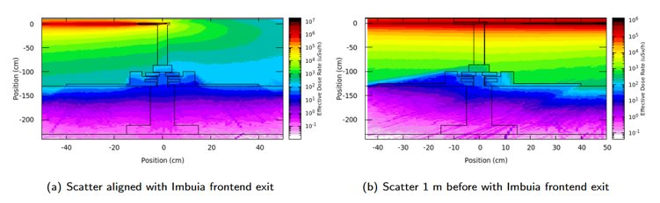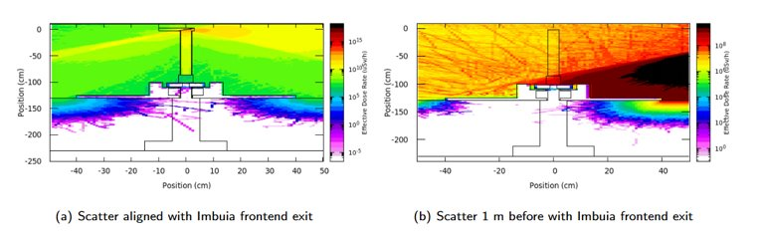
(a) Electron Losses (b) Synchrotron Scattering
Fig.2 – Dose distribution maps from internal front-end radiation simulations.

Externally, the shielding hutch enclosing mirrors M2, M3, and M4 combines steel and lead walls whose thicknesses were optimized through FLUKA simulations.
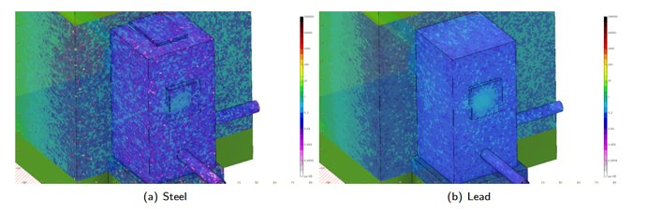
(a) Electron Losses - Steel (b) Electron Losses - Lead
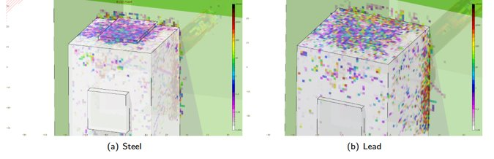
(c) Synchrotron Scattering - Steel (d) Synchrotron Scattering - Lead
Fig.3 – Dose maps from simulations of external shielding hutch used to define steel and lead wall thicknesses.

Throughout the design and construction process, iterative feedback between simulation results and engineering implementation refined the shielding strategy, with the final solution adopted shown in Figure 4, with first beam was measured in February 2021.

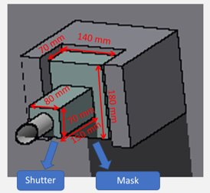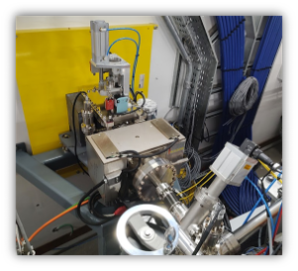
(a) Front-end
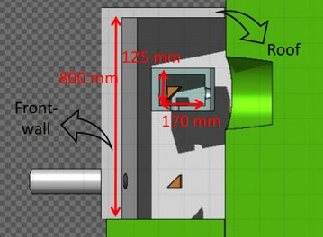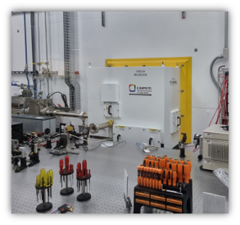
(b) Hutch
Fig.4 – Geometry of the IMBUIA simulated in FLUKA and corresponding constructed shielding components.

- SAPÊ Beamline (UV-C)

The SAPÊ beamline is designed for Angle Resolved Photoemission Spectroscopy (ARPES), utilizing ultraviolet C (UV-C) radiation with energies ranging from 8 to 60 eV to investigate electronic structures at the atomic scale. The beam is extracted from the Sirius storage ring’s low-field bending magnet (B2) and travels through two mirrors within the front-end before exiting the concrete shielding, a configuration similar to other insertion device beamlines.
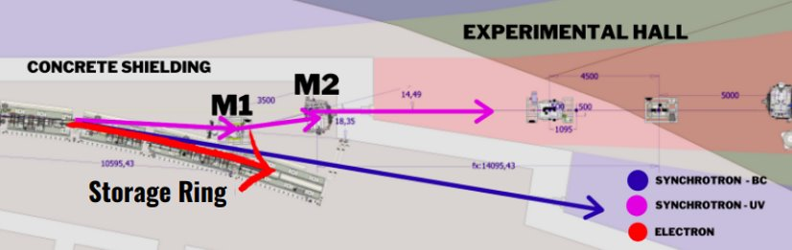
Fig.5 – Schematic overview of the SAPE layout showing mirror positions, extraction path and radiation sources.

This detailed modeling incorporated the tungsten shutter, lead reinforcements, steel wall, layered steel and polyethylene plates, and a lead block positioned to attenuate Gas Bremsstrahlung radiation originating from the straight section aligned with the beamline front-end.

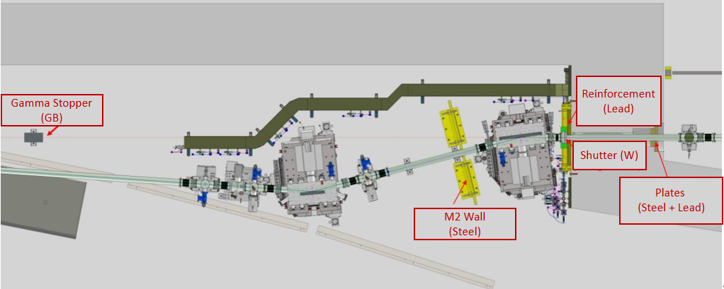
Fig.6 – Schematic of the SAPE shielding elements.

The internal front-end simulations, depicted in the dose distribution maps of Figure 7, were crucial in optimizing the dimensions and locations of the tungsten shutter and various shielding plates. The tungsten shutter was carefully dimensioned to effectively limit both direct beam exposure and scattered radiation into the front-end while ensuring operational maneuverability.

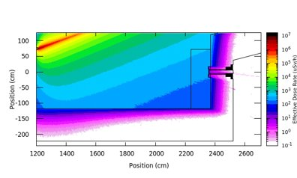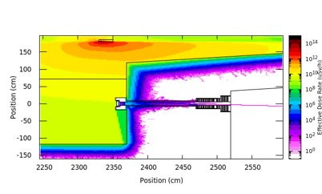
(a) Electron Losses – Closed Shutter (b) Synchrotron Scattering - Closed Shutter
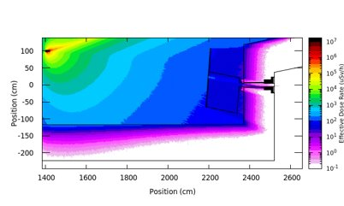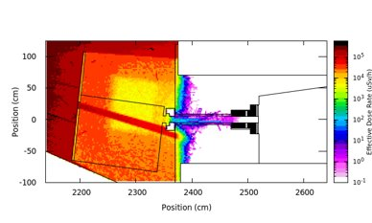
(c) Electron Losses – Opened Shutter (d) Synchrotron Scattering - Opened Shutter
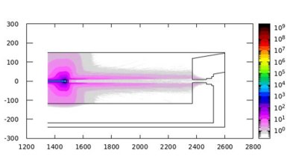
(e) Gas Bremsstrahlung
Fig.7 – Dose distribution maps from internal front-end radiation simulations.

The external shielding elements, modeled in subsequent simulations shown in Figure 3, consist primarily of a 40 mm thick steel wall with a 102 mm diameter aperture aligned to the beam path. This wall, supplemented by layers of steel and polyethylene plates, was optimized to minimize scattered radiation penetrating beyond the concrete wall and to comply with dose limits. Additionally, a lead block was installed immediately outside the front-end exit to reduce the dose originating from Gas Bremsstrahlung radiation transported along the beamline axis.
Successive adjustments informed by the comparison between simulation outcomes and shielding design decisions directed the final engineering plans and installation process, ensuring that radiation levels outside the shielding consistently comply with regulatory standards.

- CARCARÁ Beamline (Visible + 11 keV X-Ray)

The CARCARÁ beamline at Sirius serves as an advanced diagnostic tool for the electron beam, utilizing two distinct branches to characterize different aspects of the beam. The CARCARÁ-X branch focuses on electron beam emittance measurement by forming high-resolution 11 keV x-ray images through a system composed of a toroidal multilayer mirror, a Bragg crystal magnifier, and a detector. The CARCARÁ-V branch extracts visible light at 90º laterally from the B1 dipole magnet for temporal beam characterization via a streak camera.
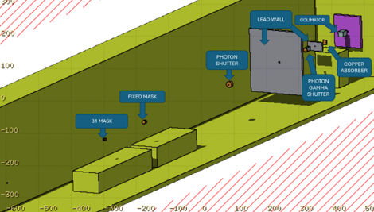
Fig.8 – Schematic overview of the CARCARA frontend layout.

Radiation sources relevant to shielding design include electron losses concentrated at the scrapers, synchrotron photon scattering within the machine, and Gas Bremsstrahlung emitted by electrons interacting with residual gas atoms inside the vacuum chamber. The electron loss scenarios were derived from data provided by the accelerator physics group, spanning different scraper aperture settings for machine studies and normal operation.
The shielding elements include copper and tungsten masks, photon shutters, lead walls, and absorbers specifically dimensioned to mitigate scattered photons and secondary radiation from electron losses and synchrotron sources. Simulation-driven optimization identified minimum thickness requirements for elements.
Dose maps (Figure 9) for electron losses impacting both inboard and outboard scraper blades show that attenuation provided by the front-end elements reduces dose rates outside the concrete shielding below the regulatory limit in the experimental hall.

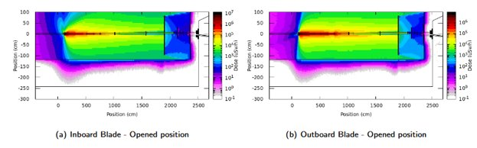
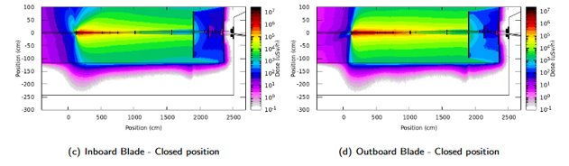
Fig.9 – Dose distribution maps from electrons losses in scrapper radiation simulations.

Gas Bremsstrahlung contributions, analyzed under conservative assumptions for beam current and vacuum pressure, also resulted in dose levels below the acceptable threshold (Figure 10).
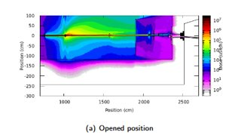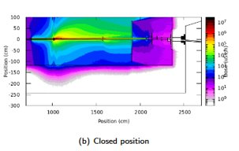
Fig.10 – Dose distribution maps from Gas Bremsstrahlung radiation simulations.

Iterative refinements between simulation outputs and shielding design guided the final mechanical drawings and installation, guaranteeing radiation levels outside the shielding remain within the regulatory thresholds.

- Conclusions

This study provides a practical methodology for radiation shielding design adapted to non-traditional synchrotron beamlines extracting IR, visible, and UV radiation. Tailored shielding geometries and materials based on Monte Carlo simulations ensure compliance with dose limits and operational safety. The shielding design for the SAPÊ and CARCARÁ beamlines was particularly challenging due to the deliberate design premise of not having shielding hutches with protective walls outside the concrete ring shielding; consequently, no spatial restrictions exist outside the concrete shielding walls to prevent potential exposures, requiring highly optimized front-end shielding solutions.
Integrated radiation monitors were employed during initial beam commissioning and regular operation of all three beamlines. Results consistently demonstrated dose levels below background outside shielding zones, validating simulation predictions and supporting the chosen radiation protection strategies. The approach is flexible and scalable for future beamline projects, promoting innovative synchrotron use without compromising radiological safety.

Acknowledgments: The authors thank high-performance computing resources essential to this work provided by the National Laboratory for Scientific Computing (LNCC/MCTI, Brazil).

References

[1] F.Cerutti et al., “New Capabilities of the FLUKA Multi-Purpose Code”, Frontiers in Physics 9, 788253 (2022). ISSN: 2296-424X

